Monday  9/24/2018 | Tuesday  9/25/2018 | Wednesday  9/26/2018 | Thursday  9/27/2018 | Friday  9/28/2018
Social Studies | Math | ELA | Science | Writing
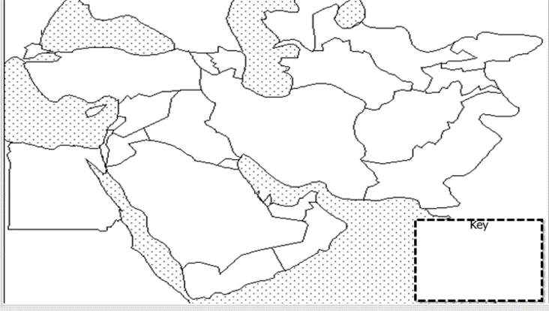  1.Label the following features:  Physical: Euphrates River, Jordan River, Tigris River, Suez Canal, Persian Gulf, Strait of Hormuz, Arabian Sea, and Red Sea.  Political: Afghanistan, Iran, Iraq, Israel, Kuwait, Saudi Arabia, Syria, Turkey, Gaza Strip, West Bank.  2. Use the population density map below to explain where people choose to live in the Middle East and why.  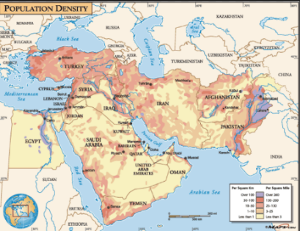 | 1) It takes Shonda 5/6 of an hour to dry one load of laundry in her dryer. How many hours will it take her to dry 7 loads of laundry?  A. 5 5/6  B. 1 1/6  C. 5/42  D. 2  2)Griffin ordered a pair of sneakers online. He had a $17 credit that he applied toward the purchase, and then he used a credit card to pay for the rest of the cost. If the shoes cost $58, how much did Griffin charge to his credit card when he bought the sneakers?  3)Lainey is sliding down a water slide that is 322 feet long at a rate of 46 feet per second. How long will it take Lainey to travel from the top to the bottom of the slide?  4) Convert the following fraction to a decimal. -3/20 | Identifying Figurative Language in Poetry  Figurative language describes ideas by comparing them to something else or adding descriptive words and phrases. There are different types of figurative language, including similes, metaphors, personification, hyperbole, and idioms.  Instructions. Read the lines of poetry. Each line is separated by a “/”. Identify the figurative language and figure out what it is trying to mean. Write the meaning on the line below.  Example: She was so sad / she cried a river of tears / She just kept crying.  She cried a lot of tears.  1. The music played loud / loud as a headache / beating on the brain. ___________________________________________________  2. Straight and tall / like a soldier / standing at attention / the tree was proud. ____________________________________________________  . Possessive Nouns  Fill in the blank with the possessive form of the noun(s) in parentheses.  - My ________________________ name is Toby. (brother)  - I love my ____________________ cookies. (grandmother)  - ______________________ car is shiny red. (Timmy)  - ______________________ coat is the plaid one. (Alexis) | - Construct a model of a plant cell and animal cell. Identify and label the structures and provide an explanation of the function of each structure. Please include the following structures:  - Nucleus  - Cytoplasm  - Cell Wall  - Chloroplasts  - Cell Membrane  - Mitochondria  - Lysosomes  2. What is this organelle?  _____________________  3.What cellular process takes place in this organelle?  ________________  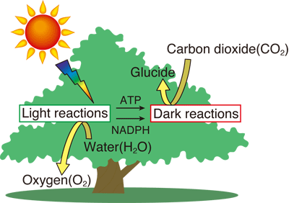  4.What cellular process does the diagram represent? What organelle does this process use?  _____________________  5.Why is homeostasis important for cells as well as for an entire organism? What are four things cells can do to maintain homeostasis? Summarize evidence to support your claim and explain your reasoning.  6.List the following terms under either Active Transport or Passive Transport: Endocytosis, Diffusion, Exocytosis, Osmosis. Create a sketch for each. | Complete drafting assignments for your Embedded Assessment 1 Narrative Assignment

