I. Reading Comprehension: Read the following newsela article. Be sure to click on the correct lexile for your article according to the lexile ranges I have created. See below. Do not forget to annotate your article as you read to receive credit for the questions. Circle the verbs, underline the nouns/noun phrases and highlight all unit vocabulary words found in the text.

*(brainPop -> search content topic -> click on newsela -> click view on newsela-> change lexile level -> sign in-> begin reading article and answer quiz questions)

Understanding tropical deforestation
0-580 ο
581-790 *
791-1020
1021-1170 ♥
1171 and up ◊

II. Technology I-BrainPop: Login to your account. Watch the video on Nitrogen Cycle and the Carbon Cycle. Take the graded quiz. You must score a 100% on the graded quiz before moving on to the next station. BrainPop (username: first name.last name last five numbers of lunch number; password: 123456 until you change it).

III. Writing: Write an expository essay related to energy and matter in ecosystems. Essay must be typed. Include five vocabulary words in your essay and underline them each time the vocabulary word is used. Please visit the link below for additional support on expository essay writing:

https://www.time4writing.com/writing-resources/types-of-essays/

*a paragraph consists of 5-7 complete sentences.

Paragraph one- Introduction
Paragraph two- Body 1
Paragraph three- Body 2
Paragraph four- Body 3 (Explain how your hands-on activity relates to energy and matter in ecosystems)
Paragraph five- Conclusion

Each day a portion of the writing process will be due and checked before the end of the class period. This will be one of the daily stations checked out of the 1.5 stations to be completed daily.
Monday | Tuesday | Wednesday | Thursday | Friday
Prewrite | Rough draft | Revise | Edit | publish
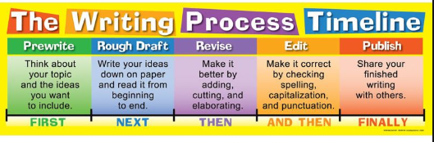

IV. Vocabulary: Choose ten words from the unit vocabulary list that are the most challenging to you to complete one of the vocabulary tasks blow (* denotes the task must be typed):

See frayer model attached.

V. Hands-On: Create a 3D modal of your choice related to Energy and Matter in Ecosystems (Be creative!) or choose from one of the tasks below (* denotes task must be typed):

Brochure | Social Media Page | Scholarly Article | Functional 3D model  ----------------------  Create a vocabulary matching game with pictures
Song/Rap/Poem | Comic Strip | Children’s Book
Poster | Textbook Recreate | Quiz*

VI. Notes: Science workbook pages on Energy and Matter in Ecosystems pg. 428-438; 1-24

VII. Technology II-Study Island: Complete the following topic(s).
- Matter & Energy in Ecosystems

*(If topics do not show on home screen then click on GA programs on the left side of screen. Click on 7th grade. Topics should populate. Click on above topics and begin.)

VIII. Graphic Organizer
- Create a graphic organizer about the carbon cycle and nitrogen cycle.

IX. Observation, Inference and Prediction
Find and print a picture related to Energy and Matter in Ecosystems. Write an observation about the picture in a complete sentence. Write an inference about the picture in a complete sentence and write a prediction about the picture in a complete sentence.

